Seed Demand Form
- Fill all requied fields in form.

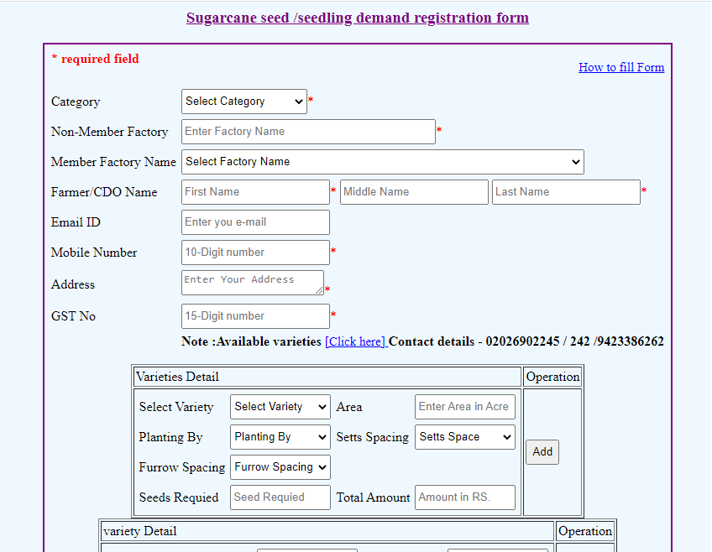

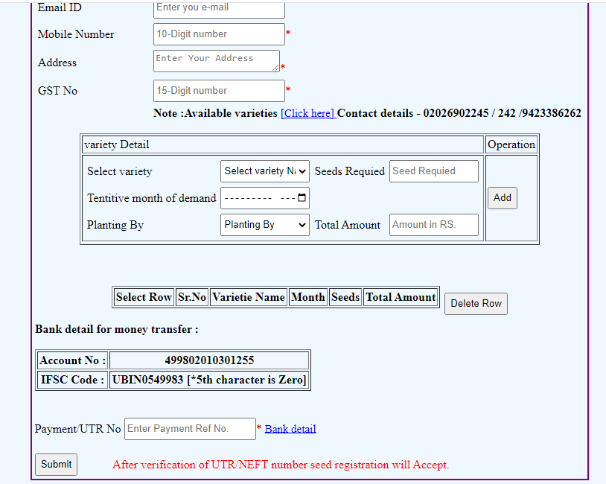
- After filling form click on submit button.
- After clicking on submit button you will gate “successfully registration” message.
- After verification of UTR/NEFT number seed registration will accept.

